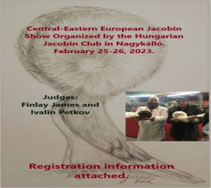
Name:…………………………………………………………… First name:……………………………………………………………..
Full adress (country too):…………………………………………………………………………………………………………………
Telefon:……………………………………………………………………………………………………………………………………………
Email:……………………………………………………………………………………………………………………………………………….
Number | Young cock 1-0 | Young hen 0-1 | Old  cock 1-0 | Old  hen 0-1 | Colour & variety | Entry fee
1
2
3
4
5
6
7
8
9
10
11
12
13
14
15
16
17
18
19
20
Registration deadline 2023.02.12.  Entry fee: 6 eur x ……/ number |  |  |  | Total amount entry fee
Exchange cage: 3 eur x ……number |  |  |  | Total amount exchange cage
Registration fee and  Required catalogue: 10 eur |  |  |  | Registration fee and  Required catalogue |  | 10 eur
To return to: Istvan Jurasko  email: jurasko.istvan@gmail.com |  |  |  | Donation
Pay the total sum: Ferenc Harsanyi  HU07104044678252485748481033  BIC: OKHBHUHB |  |  |  | Total amount

………………………………………………………………………………..
Signature of exhibitor

